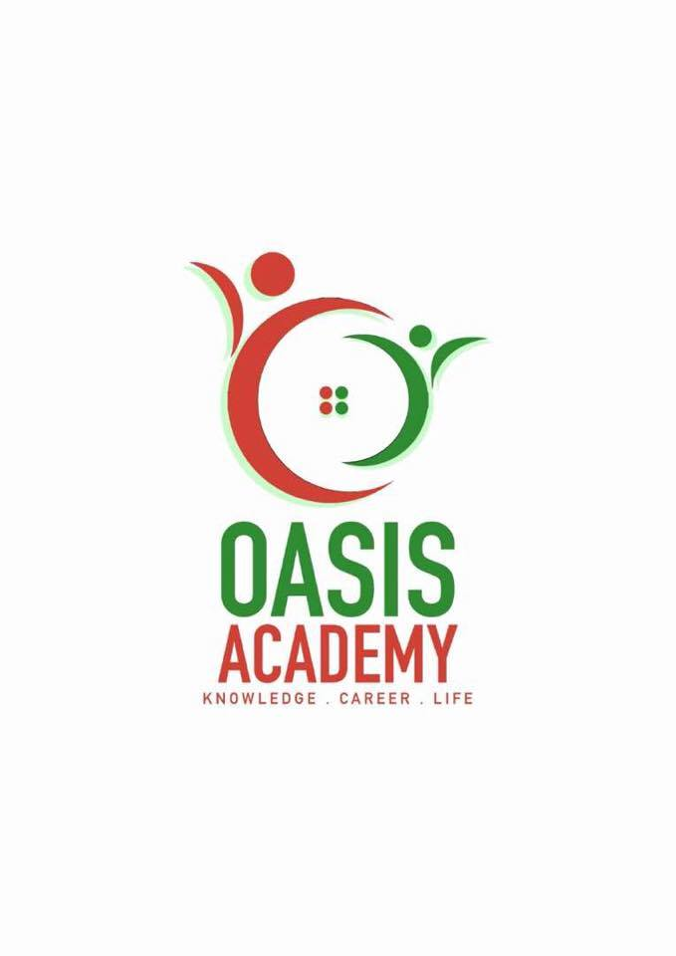

**Name:**  Vivshnu Gunasegaran

**Login ID**: vivshnu@oasis-portal.com

**Course title:** Essentials of Human Resource

**Subject Code**: BHM01

Submitted date: 4/6/2017

**Table of Contents**

|  |  |  |
| --- | --- | --- |
| No | Details | Page |
| 1 | Executive Summary | 3 |
| 2 | Introduction | 4 |
| 3 | Part 1 | 5-7 |
|  | Part 2 | 8-12 |
|  | Part 3 | 13-15 |
|  | Part 4 | 16-18 |
| 4 | Conclusion | 19 |
| 5 | References | 20 |
|  | Appendix | 21 |

**Executive Summary**

The motivation behind doing this task is to give knowledge of HRM part in the association. In the first place, we talked about meaning of HR, consistently we additionally examined on the focuses significant exercises, which are payrolls, benefits, enrollment, preparing and wellbeing and security also.

At that point we clarified a little profundity about re-designing work handle for enhanced efficiency; unexpected workforce; mass customization; decentralized work destinations; worker's inclusion.

In addition, in the third part we have clarified about the payrolls; benefits; enlistment; preparing and furthermore wellbeing and security in detail. As a last touch, we likewise expressed a few focuses on authoritative structures.

**INTRODUCTION**

The objective of the assignment is to being able to understand tourism and hospitality better as well as knowing the essentials in tourism and hospitality operations. Human resource includes everything identified with the business worker relationship and is about supporting and dealing with the association’s related procedures. It’s viewed as a center business work basic to the association’s viable operation.. Human resource operation and administers personnel action to ensure accurate status and record keeping for employment record. Human resources operation coordinates, collaborates and supports academic affair, the payroll department and departments and unit across campus to ensure timely and accurate processing of records associated with each faculty and staff member’s employment status. Some of the service Human resources operation does would be process employment action forms, issues employment contracts, support and guides department representatives with completions of forms and advance employment action request for approval.

Question 1 :

What is HR? HR is known as a procedure utilized by all accommodation association by adequately utilizing the greater part of the representatives to upgrade the execution. A great many people think, Human asset is just responsible for enlistment. Well HR additionally assumes an enormous part in contracting, administrating and preparing representatives too. Be that as it may, there are a couple significant exercises of human asset operation which are staffing, development, compensating, safety and health, and employees relations.

Staffing. This incorporates the exercises of enlisting new full-time or low maintenance workers, procuring contractual workers, and firing representative contracts. Staffing exercises includes, Identifying and satisfying ability needs (through enrolment, primarily).Utilizing different enlistment innovations to gain a high volume of candidates (and to channel in light of experience. Terminating contracts when is necessary. Maintaining moral procuring rehearses and lining up with the administrative environment. Writing representative contracts and arranging pay and advantages.

Development. new representatives and giving assets to proceeded with advancement is a key speculation for associations, and HR is accused of keeping up a formative way to deal with existing human resources. Development exercises include, Training and get ready new workers for their part

Giving preparing openings for instance, inward preparing, instructive projects, meetings, and so forth. to stay up with the latest in their particular fields Planning administration prospects and giving input to representatives and administrators

Compensating. Compensation and advantages are likewise inside the extent of human asset administration. This incorporates distinguishing proper pay in light of part, execution, and legitimate requirements. Compensation exercises incorporates of Setting remuneration levels to coordinate the market, utilizing benchmarks, for example, industry measures for a given occupation work . Arranging bunch medical coverage rates, retirement arranges, and different advantages with outsider suppliers

Talking about raises and other remuneration increments as well as declines with workers in the association. Guaranteeing consistence with lawful and social desires with regards to worker remuneration.

Safety and health. Accomplishing best practices in different enterprises incorporate watchful considering of wellbeing and wellbeing worries for employees. Safety and wellbeing exercises incorporates of Guaranteeing consistence with lawful prerequisites in light of occupation capacity for security measures (i.e. hard caps in development, accessible guiding for law implementation, proper security gear for scientific experts, etc.)Implementing new wellbeing measures when laws change in a given industry. Talking about security and consistence with significant government departments. Discussing wellbeing and consistence with unions

Employees relation. Representative relationship administration alludes to building up a positive workplace and overseeing connections amongst administration and representatives. Making positive worker relationship is vital on the grounds that representative fulfillment straightforwardly influences efficiency. The part of HR in representative relationship administration is fundamental since it plans preparing programs, affirms execution surveys, deals with a hot-line for worker circumstances, finishes leave conventions, and handles disciplinary and grievances issue. By following up on standard arrangements and methodology, HR guarantees appropriate business correspondence among workers and does effective peace making.

Question 2

The universe of work is quickly evolving. As a piece of association, Human Asset Administration (HRM) must be set up to manage impacts of changing universe of work. For the HR individuals it implies understanding the ramifications of globalization, work-drive differing qualities, changing ability prerequisites, corporate scaling back, consistent change activities, re-building, the unforeseen work compel, decentralized work locales and representative inclusion for which all and more have the money related ramifications to association. Let alone on the representatives side where engagement, fulfillment, inspiration, maintenance, non-attendance, turnover must be checked. Generally speaking human asset administration needs to wander into new patterns so as to stay applicable corporate improvement accomplice. The arranging patterns are globalization and it's suggestions, work-constrain assorted qualities, changing expertise prerequisites, corporate scaling back and consistent change programs.

Globalization and its implications. Business today doesn't have national limits ,it stretches far and wide. The ascent of multinational partnerships puts new prerequisites on human asset administrators. The HR division needs to guarantee that the fitting blend of representatives as far as information, aptitudes and social versatility is accessible to deal with worldwide assignments. With a specific end goal to meet this objective, the associations must prepare people to address the difficulties of globalization. The representatives must have working learning of the dialect and culture as far as qualities, ethics, traditions and laws of the host country. Human Asset Administration (HRM) should likewise create instruments that will help multicultural people cooperate. As foundation, dialect, custom or age contrasts turn out to be more common, there are signs that representative clash will increment. HRM would be required to prepare administration to be more adaptable in its practices. Since tomorrow's laborers will come in various hues, `nationalities et cetera, chiefs will be required to alter their way of life. This will require administrators being prepared to perceive contrasts in laborers and to acknowledge and even commend these distinctions.

**Work-force diversity. In the past HRM was impressively easier in light of the fact that our work drive was strikingly homogeneous. Today's work compel includes individuals of various sex, age, social class sexual introduction, values, identity qualities, ethnicity, religion, instruction, dialect, physical appearance, conjugal status, way of life, convictions, belief systems and foundation attributes, for example, geographic cause, residency with the association, and financial status and the rundown could go on. Differing qualities is basically connected to the association's key heading. Where assorted qualities prospers, the potential advantages from better imagination and basic leadership and more noteworthy development can be gathered to help build association's aggressiveness. One methods for accomplishing that is through the association's advantages bundle. This incorporates HRM offerings that fall under the heading of the family neighborly association. A family well-disposed association is one that has adaptable work routines and gives such representative advantages, for example, youngster mind. Notwithstanding the assorted qualities brought by sex and nationality, HRM must know about the age contrasts that exist in today's work compel. HRM must prepare individuals of various age gatherings to successfully oversee and to manage each other and to regard the assorted qualities of perspectives that each offers. In circumstances like these a participative approach appears to work better.**

Changing skill requirements. Enlisting and creating talented work is essential for any organization worried about aggressiveness, efficiency, quality and dealing with a differing work drive viably. Ability lacks convert into huge misfortunes for the association as far as low quality work and lower profitability, increment in worker mishaps and client objections. Since a developing number of occupations will require more instruction and more elevated amounts of dialect than current ones, HRM experts and authorities should impart this to instructors and group pioneers and so forth. Key human asset arranging should painstakingly measure the expertise insufficiencies and deficiencies. HRM division should devise appropriate preparing and here and now projects to connect the ability holes and insufficiencies.

Corporate downsizing. At whatever point an association endeavors to delayer, it is endeavoring to make more prominent productivity. The start of cutting back is to diminish the quantity of specialists utilized by the association. HRM office has an essential part to play in cutting back. HRM individuals must guarantee that legitimate correspondence must occur amid this time. They should limit the negative impacts of gossipy tidbits and guarantee that people are kept educated with true information. HRM should likewise manage real cutback. HRM dept, is vital to the cutting back talks that need to occur.

Continuous improvement programs. Constant change programs concentrate on the long haul prosperity of the association. It is a procedure whereby an association concentrates on quality and constructs a superior establishment to serve its clients. This regularly includes a companywide activity to enhance quality and profitability. The organization changes its operations to concentrate on the client and to include laborers in matters influencing them. Organizations endeavor to enhance everything that they do, from enlisting quality individuals, to managerial paper preparing, to meeting client needs. Unfortunately, such activities are not something that can be effortlessly actualized, nor directed down through the many levels in an association. Or maybe, they resemble an association wide improvement handle and the procedure must be acknowledged and upheld by top administration and driven by communitarian endeavors, all through each fragment in the association. HRM assumes an imperative part in the usage of consistent change programs. At whatever point an association sets out on any change exertion, it is bringing change into the association. Now association improvement activities overwhelm. In particular, HRM must plan people for the change. This requires clear and broad interchanges of why the change will happen, what is not out of the ordinary and what impact it will have on representatives.

Question 3

## Staffing。 The accomplishment of scouts and work specialists overall is measured by the amount of positions they fill and the time it takes to fill those positions. Enlistment experts who work in-house - as opposed to associations that give choosing and staffing organizations - accept a key part in working up the business' workforce. They advance work postings, source hopefuls, screen applicants, coordinate preliminary gatherings and arrange utilizing tries with directors responsible for settling on the last selection of contenders.

## Development。Organizations must outfit agents with the gadgets imperative for their flourishing which, all things considered, infers giving new specialists wide acquaintance planning with help them move into another progressive culture. Various HR workplaces in like manner give organization get ready and capable headway. Specialist planning may be required of as of late contracted and propelled supervisors and directors on focuses, for instance, execution organization and how to manage delegate relations matters at the workplace level. Capable change openings are for laborers scanning for extraordinary open entryways or agents who need to fulfill singular goals, for instance, finishing an expert instruction. Ventures, for instance, instructive cost help and instructive cost reimbursement programs much of the time are inside the area of the HR get ready and progression zone.

Compensating。Human resource work constrain gives a reasonable procedure to choosing how much agents should be paid for playing out particular occupations. Pay is unmistakably related to the upkeep of HR. Since pay is a significant cost to various affiliations, it is a critical thought in human resource orchestrating. Compensation impacts staffing in that people are generally pulled into affiliations offering a bigger measure of pay as an end-result of the work performed. It is related to agent headway in that it gives an essential stimulus in motivating specialists to bigger measures of occupation execution and to higher paying businesses in the affiliation.

## Safety。Working condition security is a basic variable. Under the Word related Prosperity and Prosperity Exhibition of 1970, organizations have a pledge to give a secured work environment to delegates. One of the standard components of HR is to support workplace security planning and keep up administratively summoned logs for work space mischief and setback specifying. In like manner, HR prosperity and peril specialists much of the time work personally with HR benefits experts to manage the association's workers compensation issues.

Employee Relations。In a unionized work environment, the specialist and work relations components of HR may be solidified and managed by one expert or be inside and out independent limits administered by two HR experts with specific dominance in each range. Delegate relations are the HR prepare stressed with strengthening the business specialist relationship through measuring work satisfaction, agent engagement and settling workplace battle. Work relations limits may consolidate making organization response to union dealing with fights, masterminding total managing attestations and rendering interpretations of laborer's association contract issues.

Question 4

Organizational behavior depends on the review why individuals carry on as they do in various circumstance in an association. In the cordiality business the workers conduct rises as casual or formal conduct of the individual and gatherings. Here every one of the representatives work towards enhancing hierarchical conduct. Unquestionably, there are contrasts between person when they are set in comparable circumstances whereby, every one of the general population don't act alike. There are sure central textures hidden the conduct of all people that can be distinguished and after that get changed to reflect singular contrasts. Hierarchical structure is a framework that comprises of express and certain institutional guidelines and arrangements intended to blueprint how different function parts and duties are designated, controlled and facilitated. Organizational behavior is divided into managerial behavior, individual behavior, group behavior and consumer behavior. All this behaviors are based on the particular’s attitude, relation and working environment.

At its largest amount, a hierarchical structure is either brought together or decentralized. Generally, associations have been organized with concentrated authority and a characterized hierarchy of leadership. The military, for instance, is an association renowned for its profoundly concentrated structure, with a long and particular pecking order of bosses and subordinates. Be that as it may, there has been an ascent in decentralized associations, just like the case with numerous innovation new companies. This enables the organizations to stay quick, dexterous and versatile, with practically every worker accepting an abnormal state of individual office.

Four sorts of basic hierarchical structures are executed in this present reality. The in the first place, and most normal, is a useful structure. This is likewise alluded to as a bureaucratic authoritative structure and separates an organization in view of the specialization of its workforce. Most little to-medium measured organizations execute an utilitarian structure. Isolating the firm into offices comprising of advertising, deals and operations is the demonstration of utilizing a bureaucratic authoritative structure.

The second sort is basic among substantial organizations with numerous specialty units. Called the divisional or multi-divisional structure, an organization that uses this strategy structures its administration group in light of the items, activities or backups they work. A decent case of this structure is Johnson and Johnson. With a large number of items and lines of business, the organization structures itself so every specialty unit works as its own particular organization with its own leader.

Flatarchy, a fresher structure, is the third sort and is utilized among numerous new companies. As the name suggests, it straightens the pecking order and hierarchy of leadership and gives its workers a considerable measure of self-rule. Organizations that utilization this sort of structure have a fast of usage.

The fourth and last hierarchical structure is a network structure. It is additionally the most befuddling and the minimum utilized. This structure networks workers crosswise over various bosses, divisions or offices. A worker working for a matrixed organization, for instance, may have obligations in both deals and client benefit.

**Conclusion**

In a nutshell, Human resource operations plays a huge role on enhancing the company’s performance whereby, Human resources manages and handles the employees a proper management by the human resources department can lead to great success.

**References**

* <https://www.pearson.com/us/higher-education/program/Berger-Organizational-Behavior-for-the-Hospitality-Industry/PGM263665.html>
* <https://www.amazon.com/Organizational-Behavior-Hospitality-Industry-Florence/dp/0132447371>
* <https://goricastanisic.wordpress.com/2013/11/20/organisational-behaviour-in-hospitality-industry/>
* <http://icm.education/single-subject-diplomas/organisational-behaviour-hospitality-management/>
* <http://www.corporatecomplianceinsights.com/hr-function-compliance-role/>
* <http://www.corporatecomplianceinsights.com/hr-function-compliance-role/>
* <https://scholar.google.com/scholar?q=human+resource+planning+and+planning+trends&hl=en&as_sdt=0&as_vis=1&oi=scholart&sa=X&ved=0ahUKEwjWvM_2t5zUAhWJrI8KHW5iCmIQgQMIHzAA>
* <https://www.linkedin.com/pulse/15-current-trends-human-resource-management-rutaihwa-aristides-andrew>
* <http://smallbusiness.chron.com/six-main-functions-human-resource-department-60693.html>
* <http://www.corporatecomplianceinsights.com/hr-function-compliance-role/>